Mapping Urban Heat and Greening Priorities in Riyadh: A Geospatial Data Science Approach
Alhaylam Alajmi
MUSA 5500 – Geospatial Data Science in Python
Final Project Proposal – Fall 2026
- Project Overview
Riyadh is experiencing rapid urban growth in an extremely hot and arid climate, making urban heat an important environmental and planning challenge. This project will examine the spatial distribution of land surface temperature across Riyadh and investigate how heat patterns relate to vegetation, urban land cover, and population exposure. Using satellite imagery and additional spatial datasets, the project will identify areas where high surface temperatures, limited vegetation, and high population exposure overlap. The final analysis will highlight potential priority areas for urban greening and heat mitigation. The goal is not to identify specific tree-planting locations, but rather to provide a city-scale spatial assessment that can support further planning and policy evaluation.

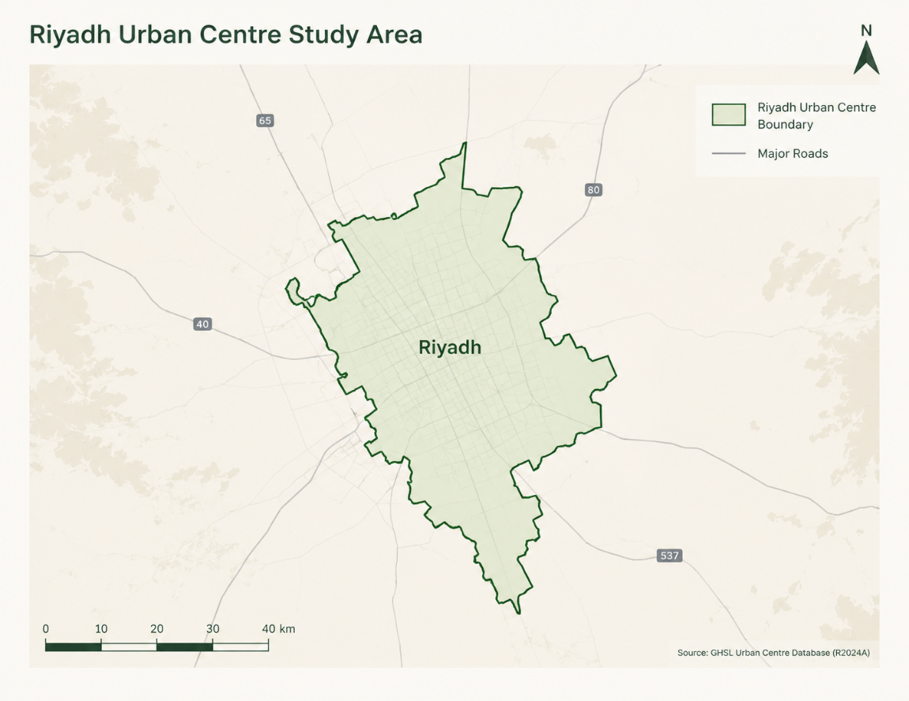

- Research Question

Where are the hottest and least vegetated populated areas in Riyadh, and which areas could be prioritized for urban greening interventions?

- Where are the major land surface temperature hotspots in Riyadh?
- How does vegetation cover relate spatially to surface temperature?
- Which populated areas experience the greatest combination of high heat and low vegetation?

- Data Sources

Dataset | Source | Purpose
Riyadh Urban Centre Boundary | GHSL / European Commission JRC | Define the study area
Landsat 8–9 Collection 2 Level-2 | USGS | Land Surface Temperature and NDVI
Population Data | WorldPop or comparable population raster | Estimate population exposure
Land Cover / Built-up Data | Dynamic World or comparable dataset | Characterize built-up and vegetation conditions

Additional datasets, such as parks or OpenStreetMap features, may be incorporated if they improve the analysis without unnecessarily expanding the project scope.

- Methodology

The project will follow a reproducible geospatial data science workflow. Landsat scenes covering Riyadh will first be processed and mosaicked, then clipped to the study boundary. Surface reflectance bands will be used to calculate NDVI, while the Landsat Level-2 surface temperature product will be used to derive land surface temperature. Population and land-cover datasets will then be aligned to a common coordinate system and spatial framework. The study area will be summarized using a regular spatial grid, allowing temperature, vegetation, built-up characteristics, and population exposure to be compared consistently across Riyadh. Exploratory spatial analysis and mapping will then be used to identify areas that combine high heat, low vegetation, and high population exposure.

- Advanced Requirements

As an individual project, this work will satisfy at least two advanced project requirements:
- Raster analysis: processing and analysis of Landsat imagery to derive land surface temperature and NDVI.
- Integration of three or more spatial datasets: combining satellite imagery, population data, and land-cover data within a common geospatial framework.
Additional interactive visualization or machine-learning components may be incorporated if they provide meaningful analytical value, but they are not required for the core project design.

- Expected Outputs

- Land Surface Temperature map
- NDVI / vegetation map
- Population exposure map
- Land-cover / built-up analysis
- Composite urban heat and greening priority map
- Interactive web-based visualizations
- GitHub repository containing code, data documentation, and methodology
- Final project report and presentation

- Scope and Limitations
The priority areas identified by this project will represent areas for further evaluation rather than direct recommendations for tree planting. Actual implementation decisions would require additional information such as land ownership, irrigation availability, utilities, street geometry, and vegetation suitability. The analysis will therefore focus on identifying spatial patterns and relative priority rather than prescribing specific interventions.

This project is designed to remain focused enough for the course timeline while still demonstrating a complete geospatial data science workflow from data acquisition through analysis, visualization, and communication.

